**Power BI Hands-on Assessment**

**Scenario:** Sales Performance Analysis with Power BI

**MANYA AGARWAL**

**Emp Id : 654801**

1. **Data Loading**

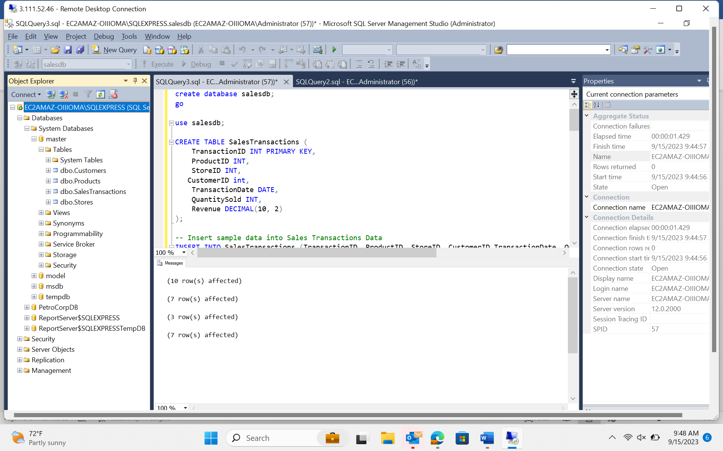

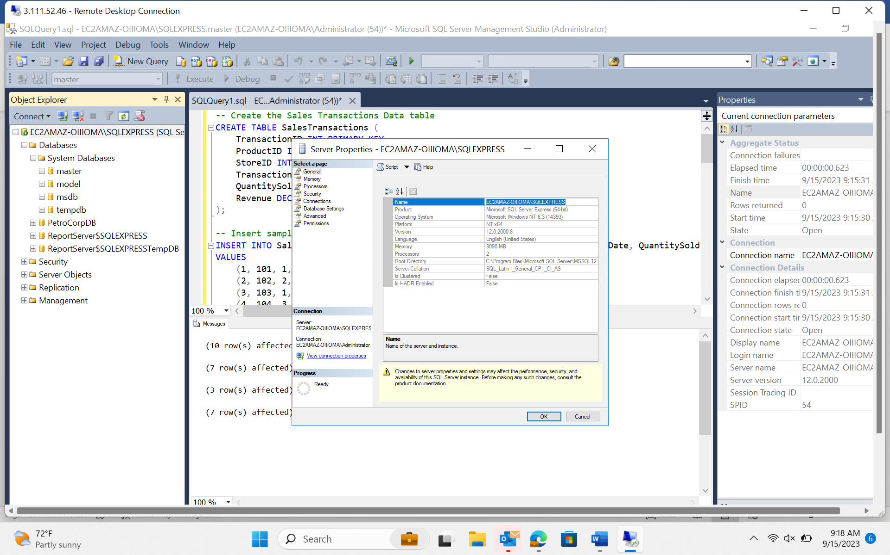

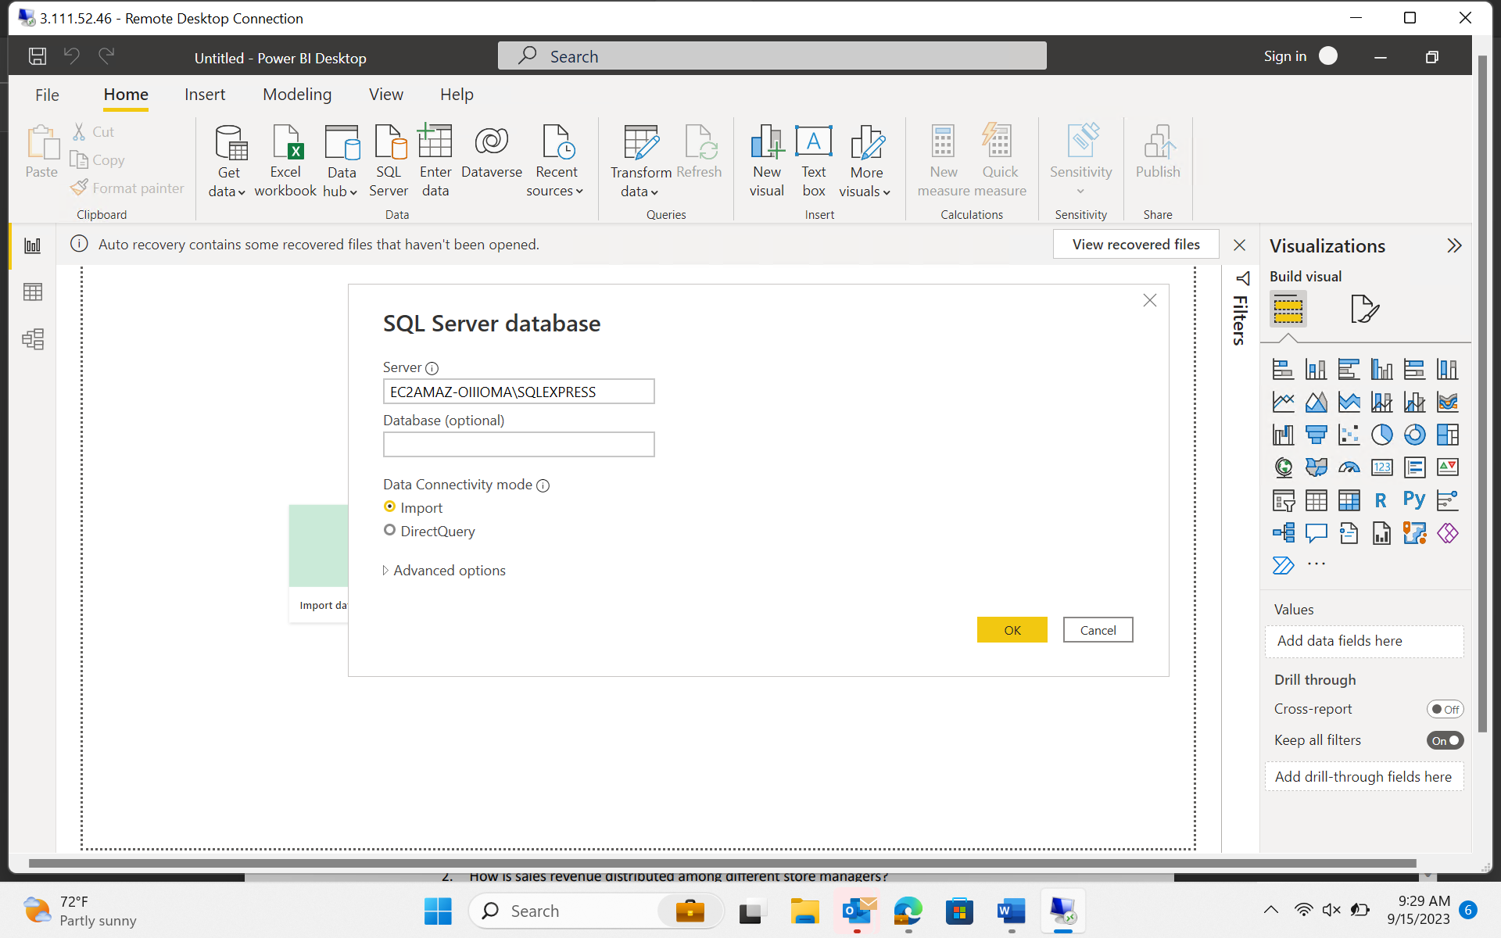

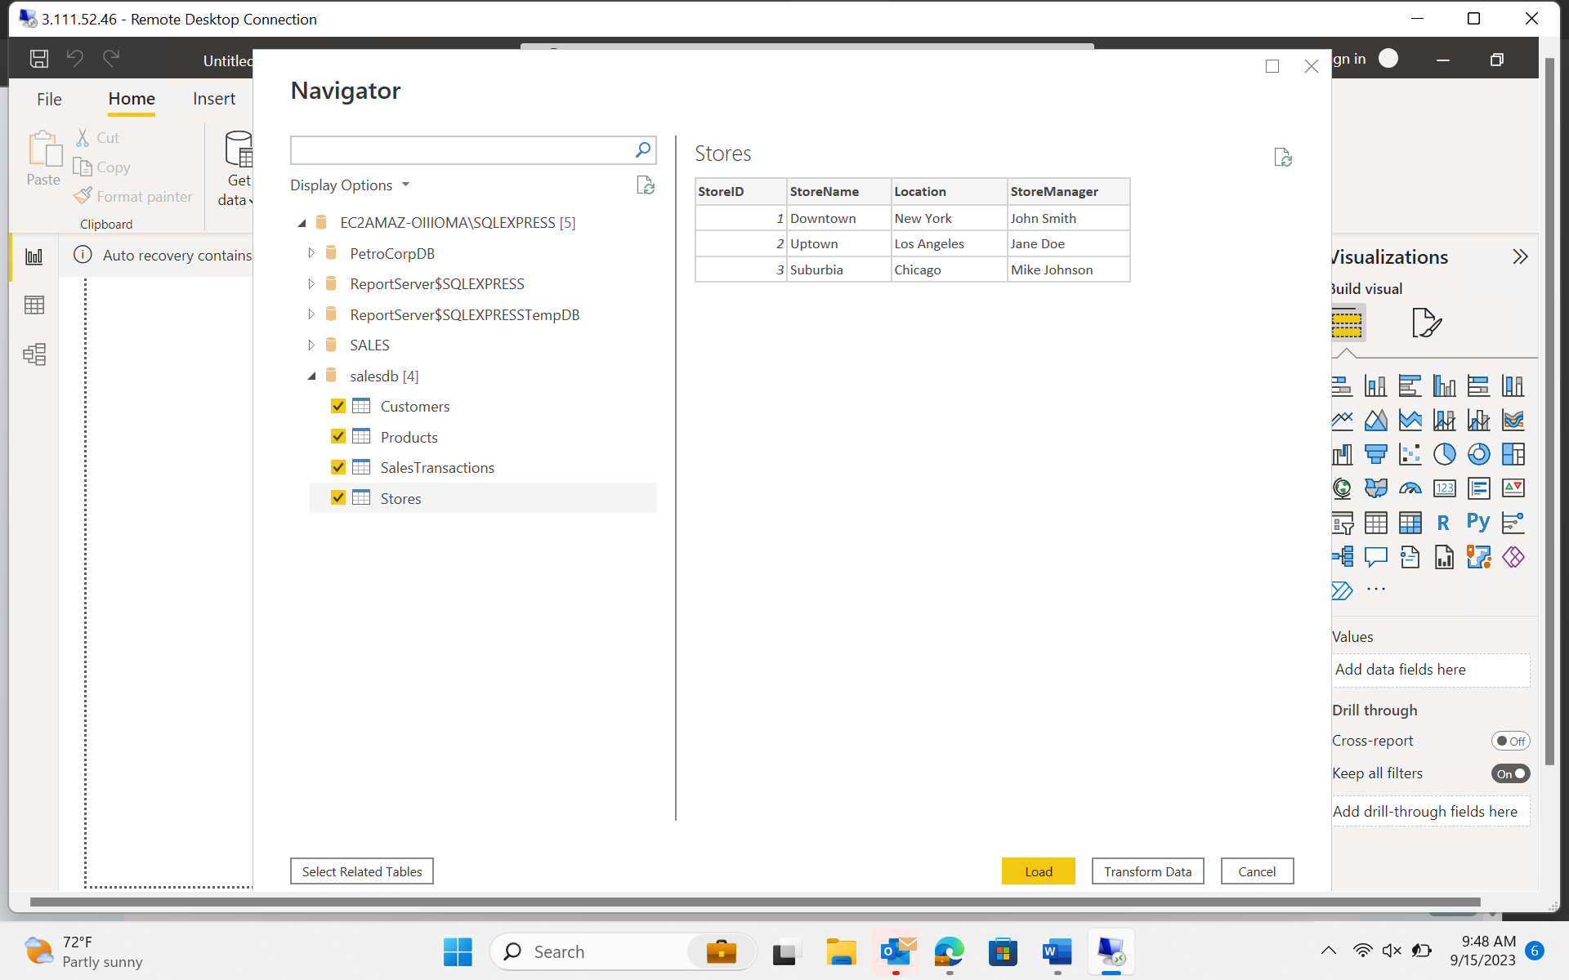

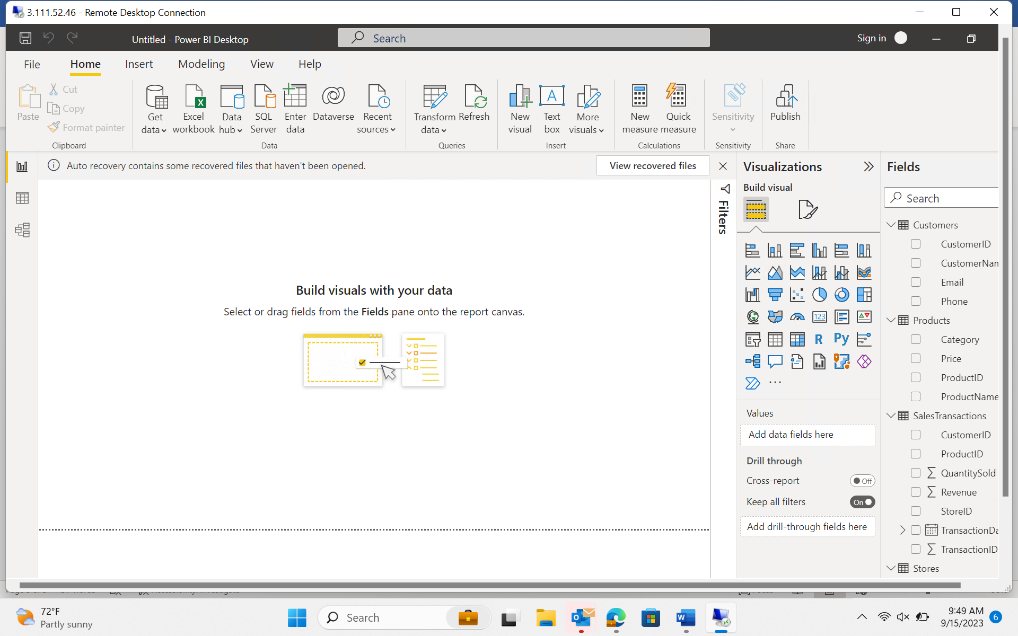

1. **Data Transformation**

* **Manage Relationships**

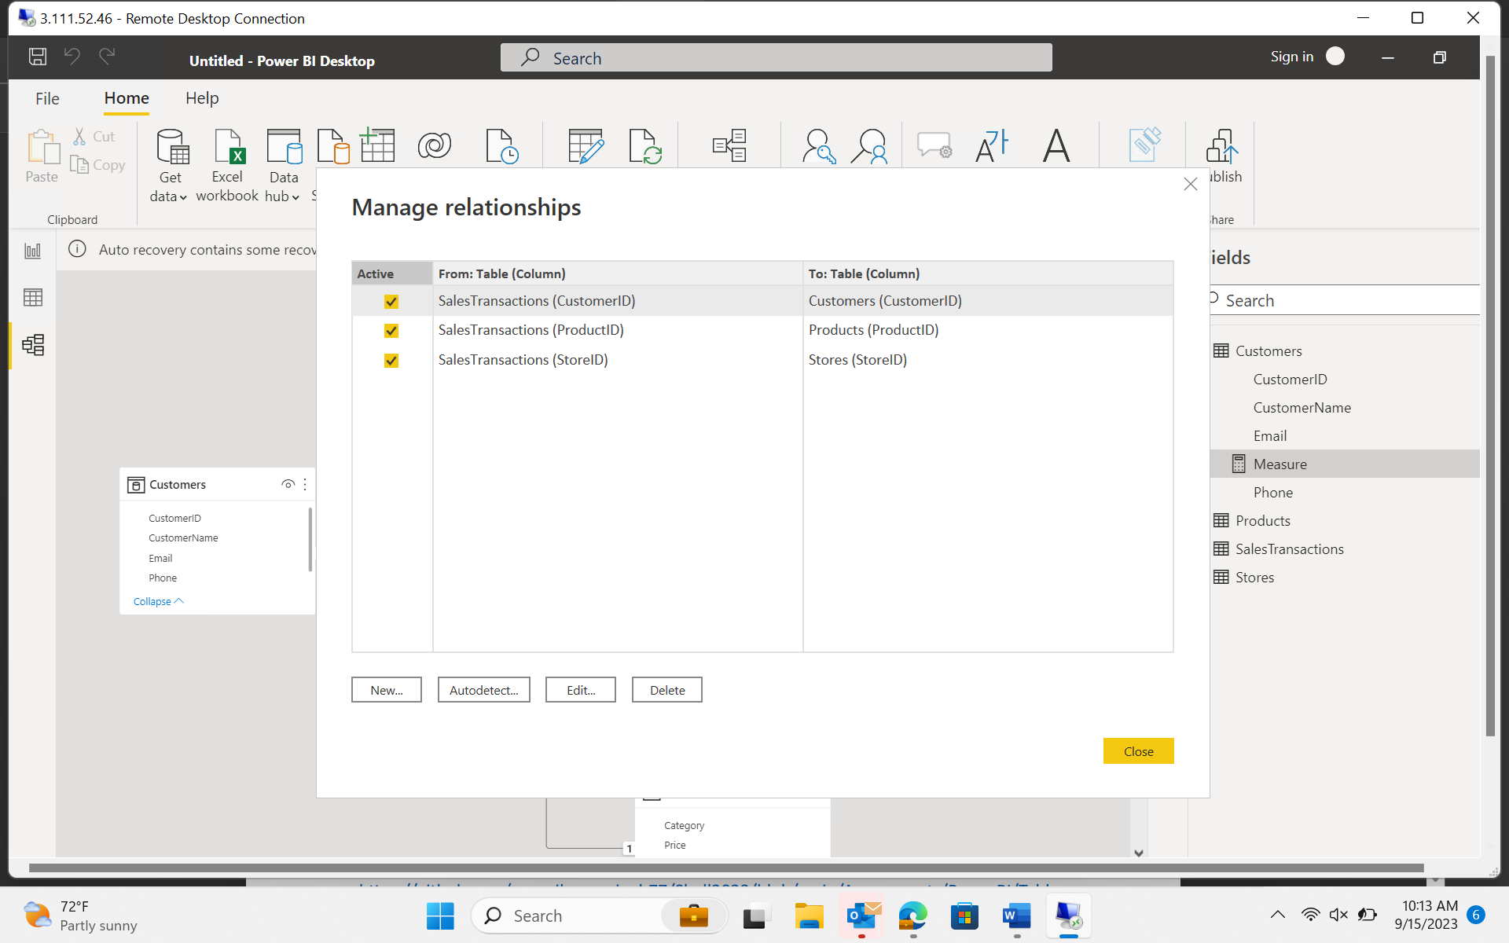

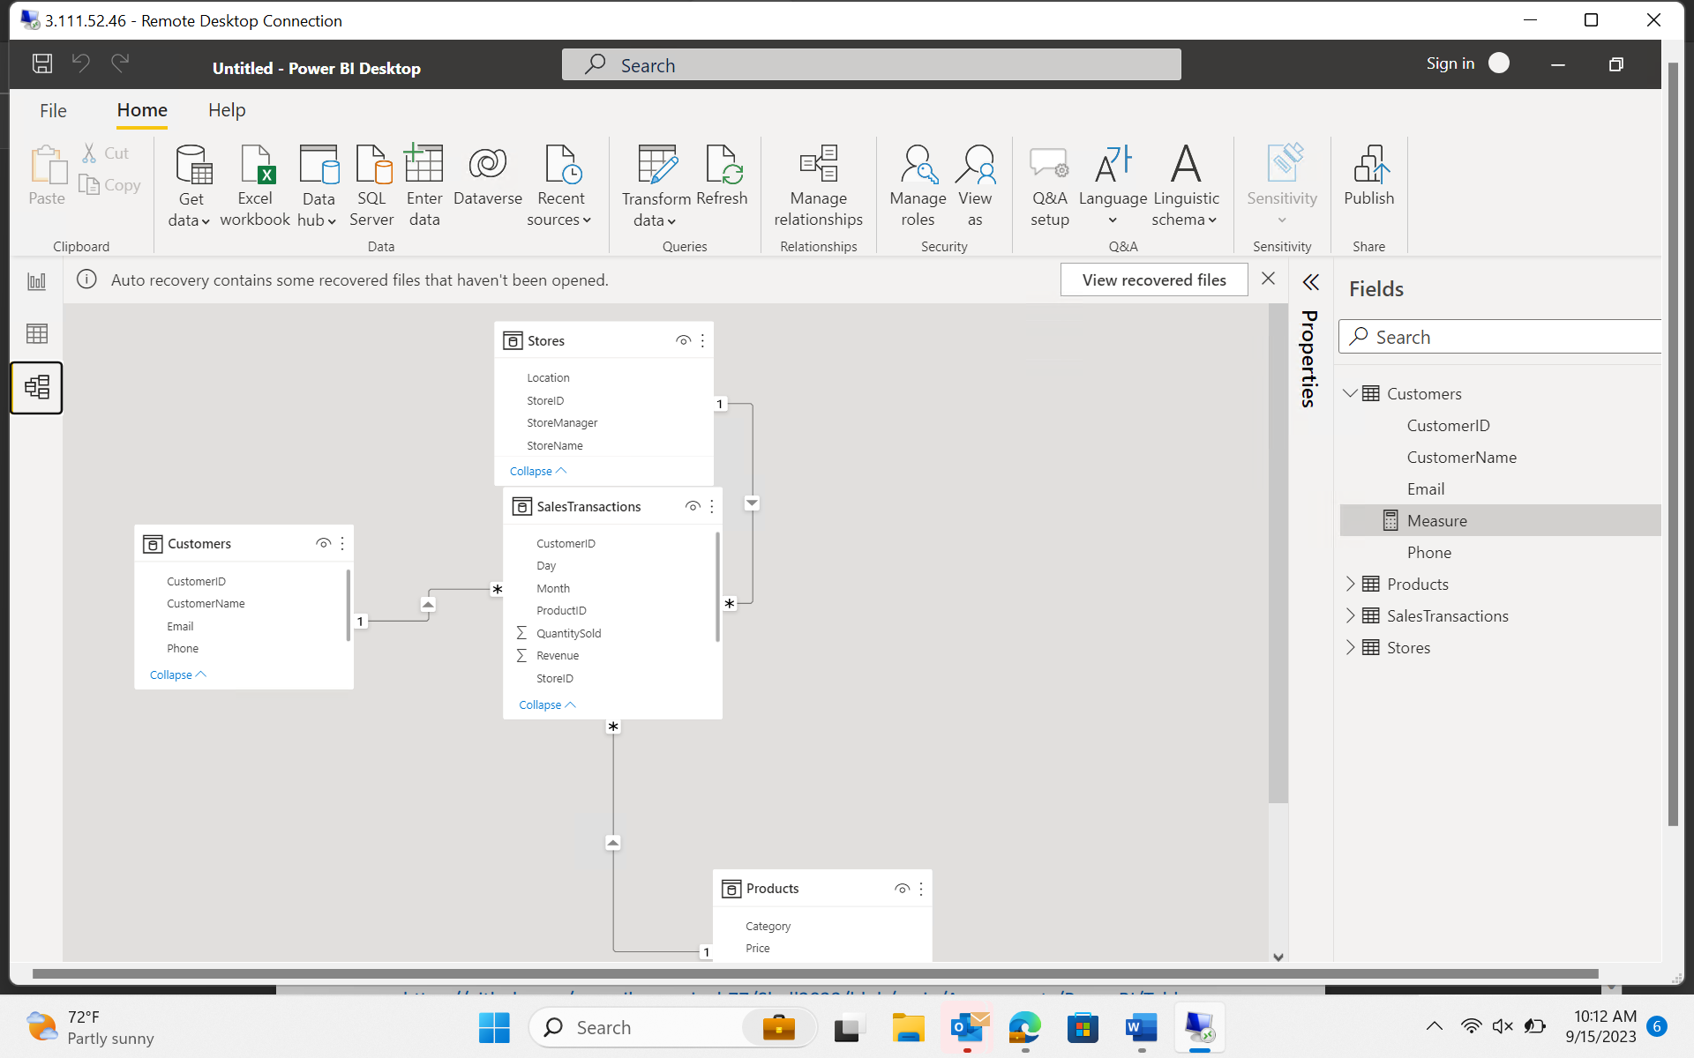

* **Clean Data :**

Transform Data

Can Remove Duplicates

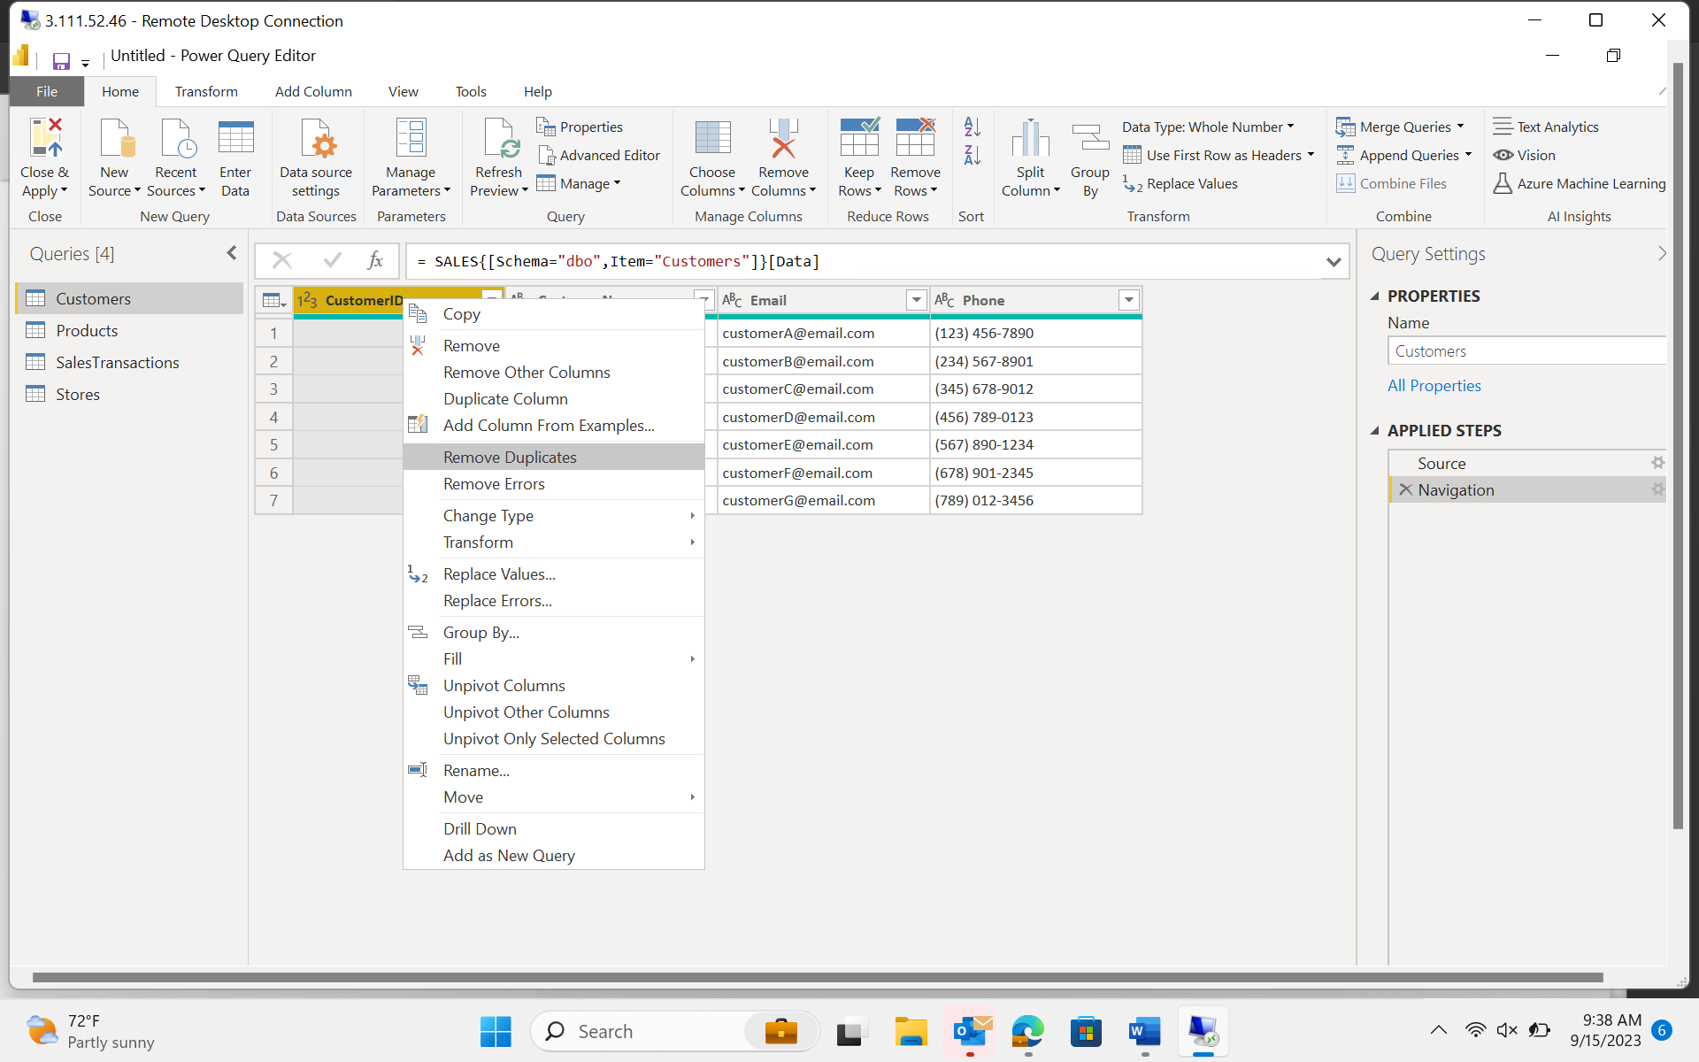

Change DataType

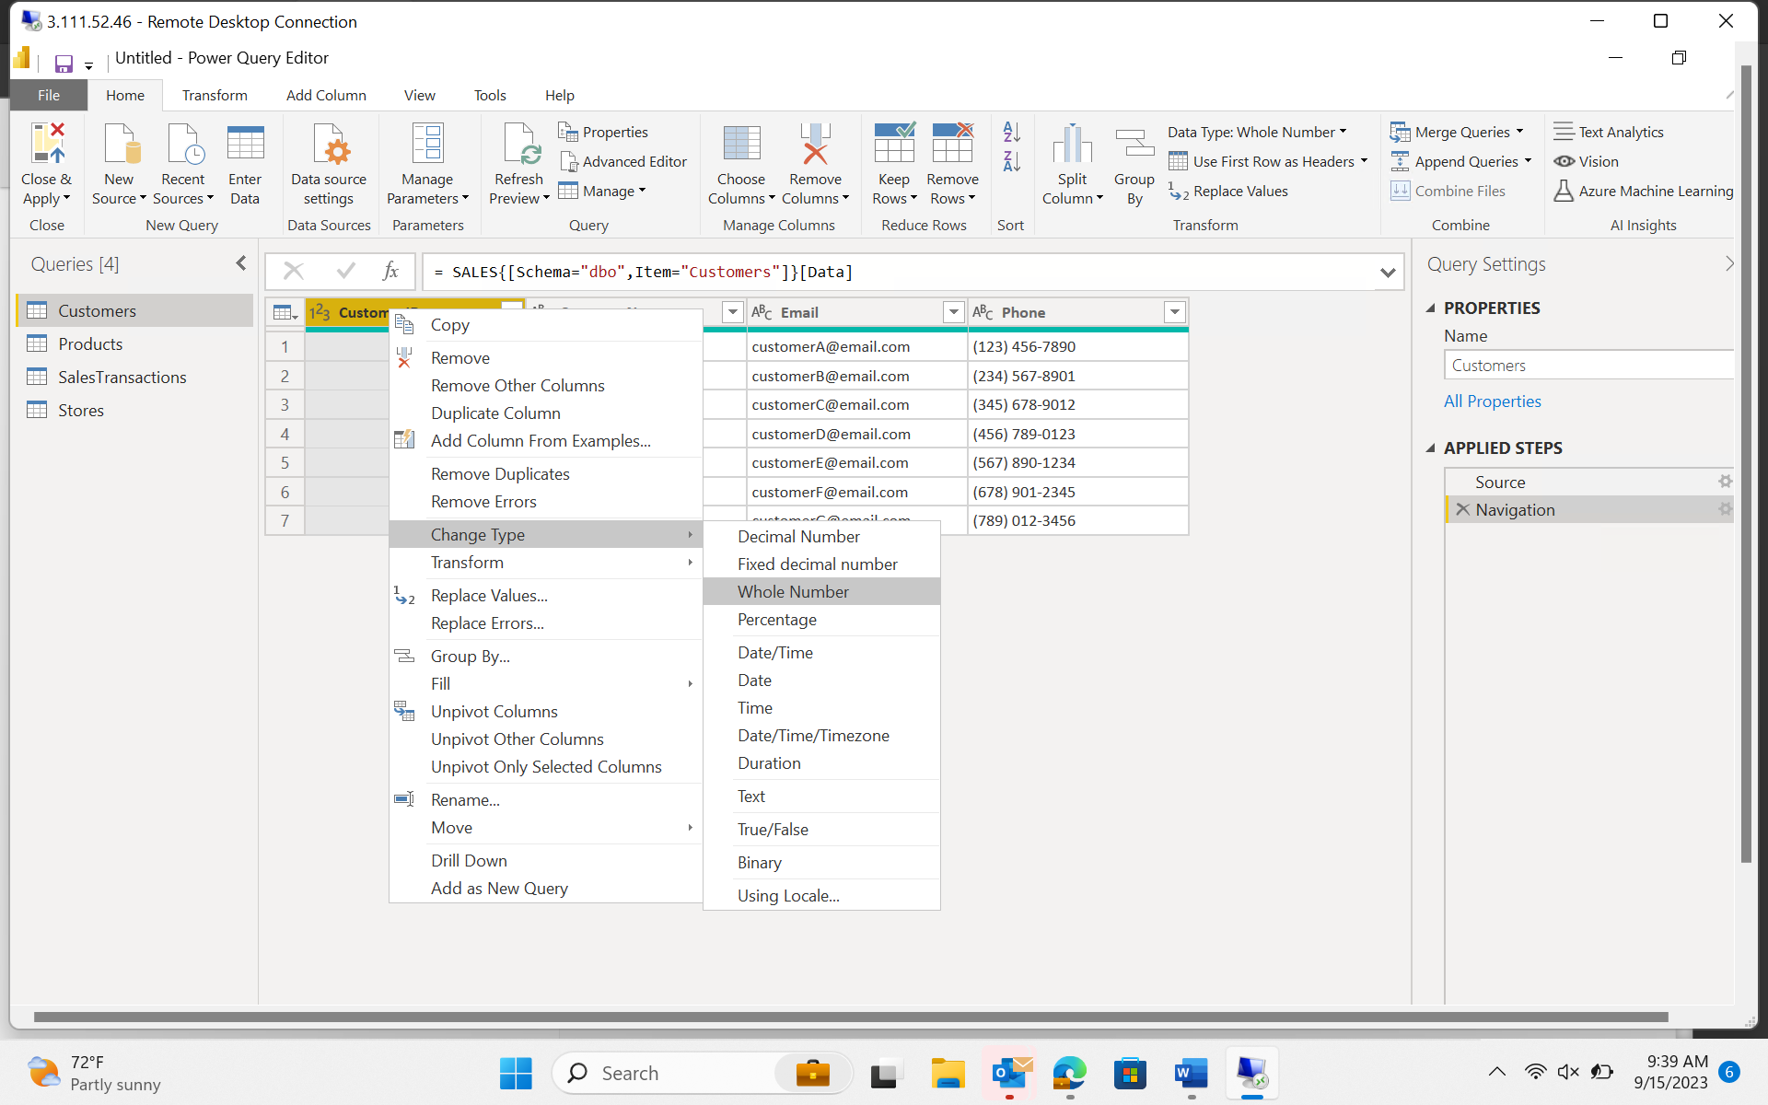

Suppose you want to keep only top 3 customers

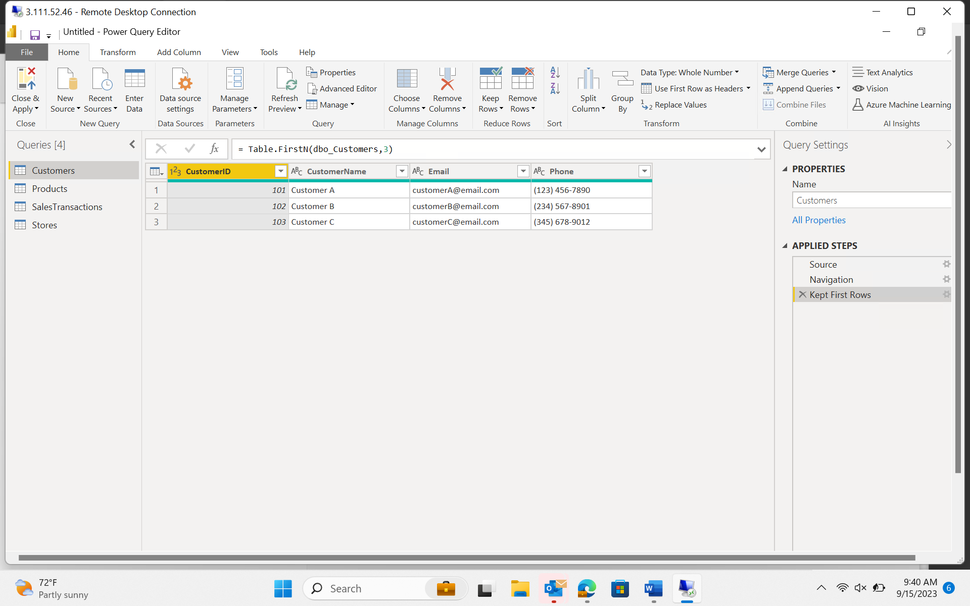

**Create Calculated Columns**

Created day/month/year from transaction date.

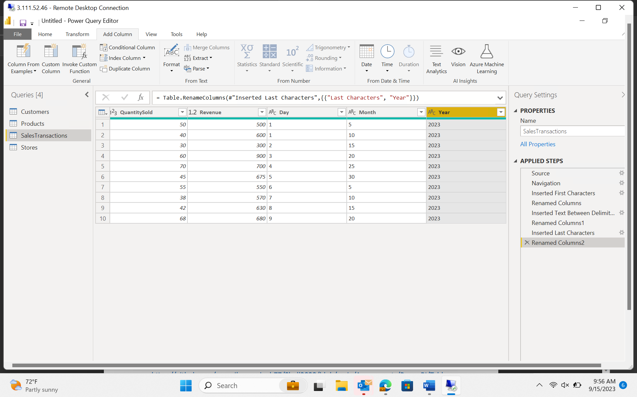

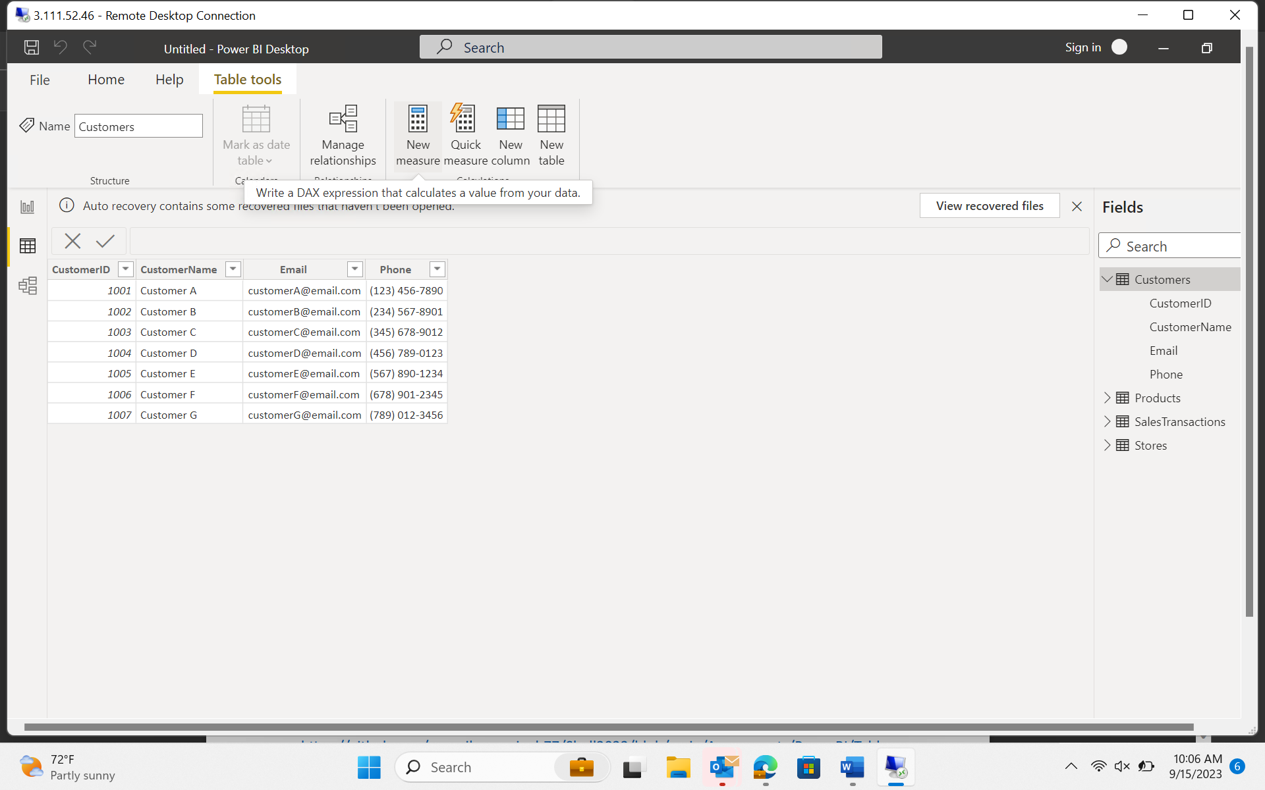

Calculated day of week

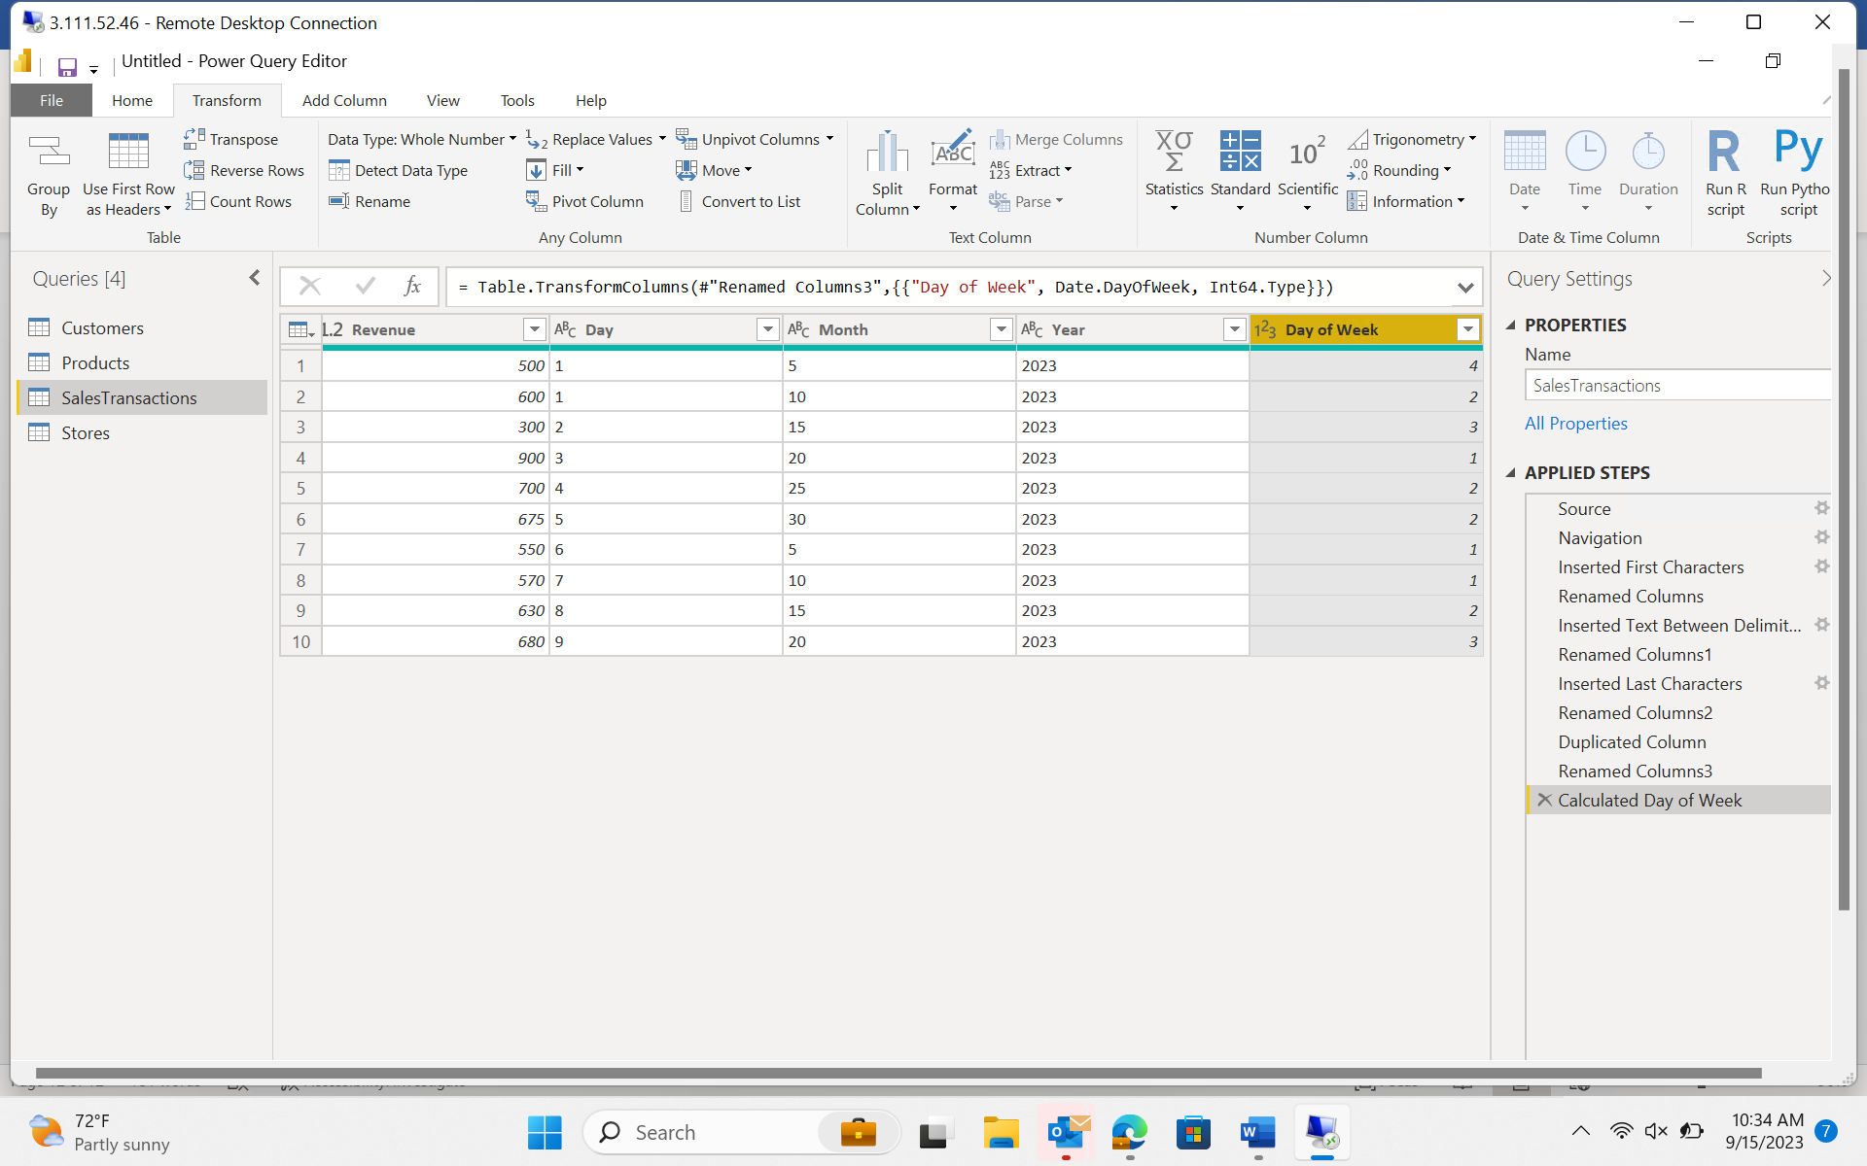

Filter Data

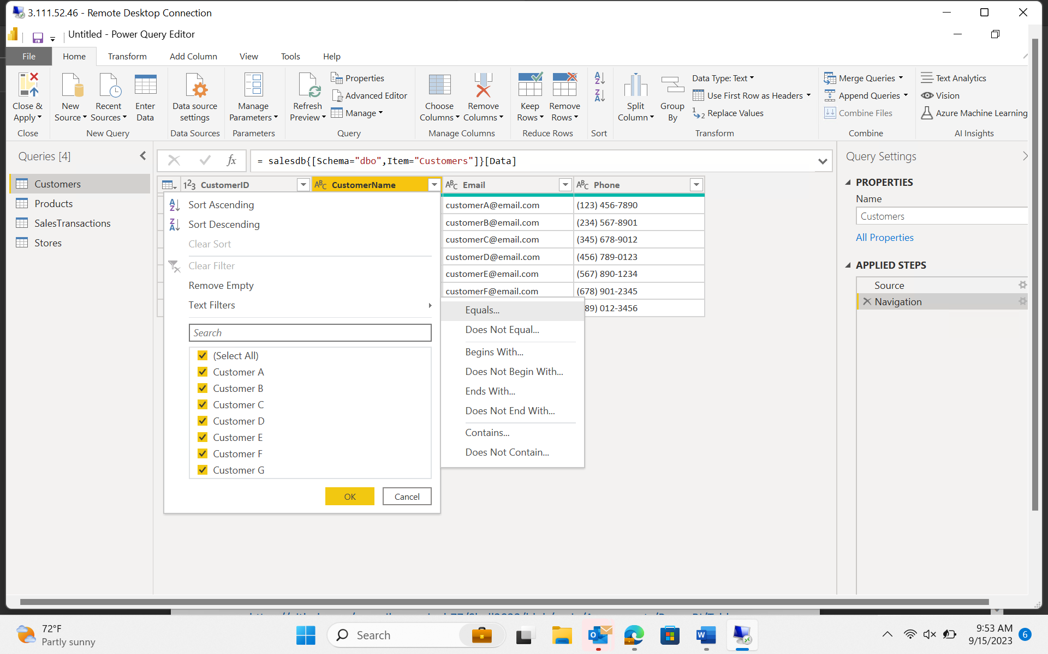

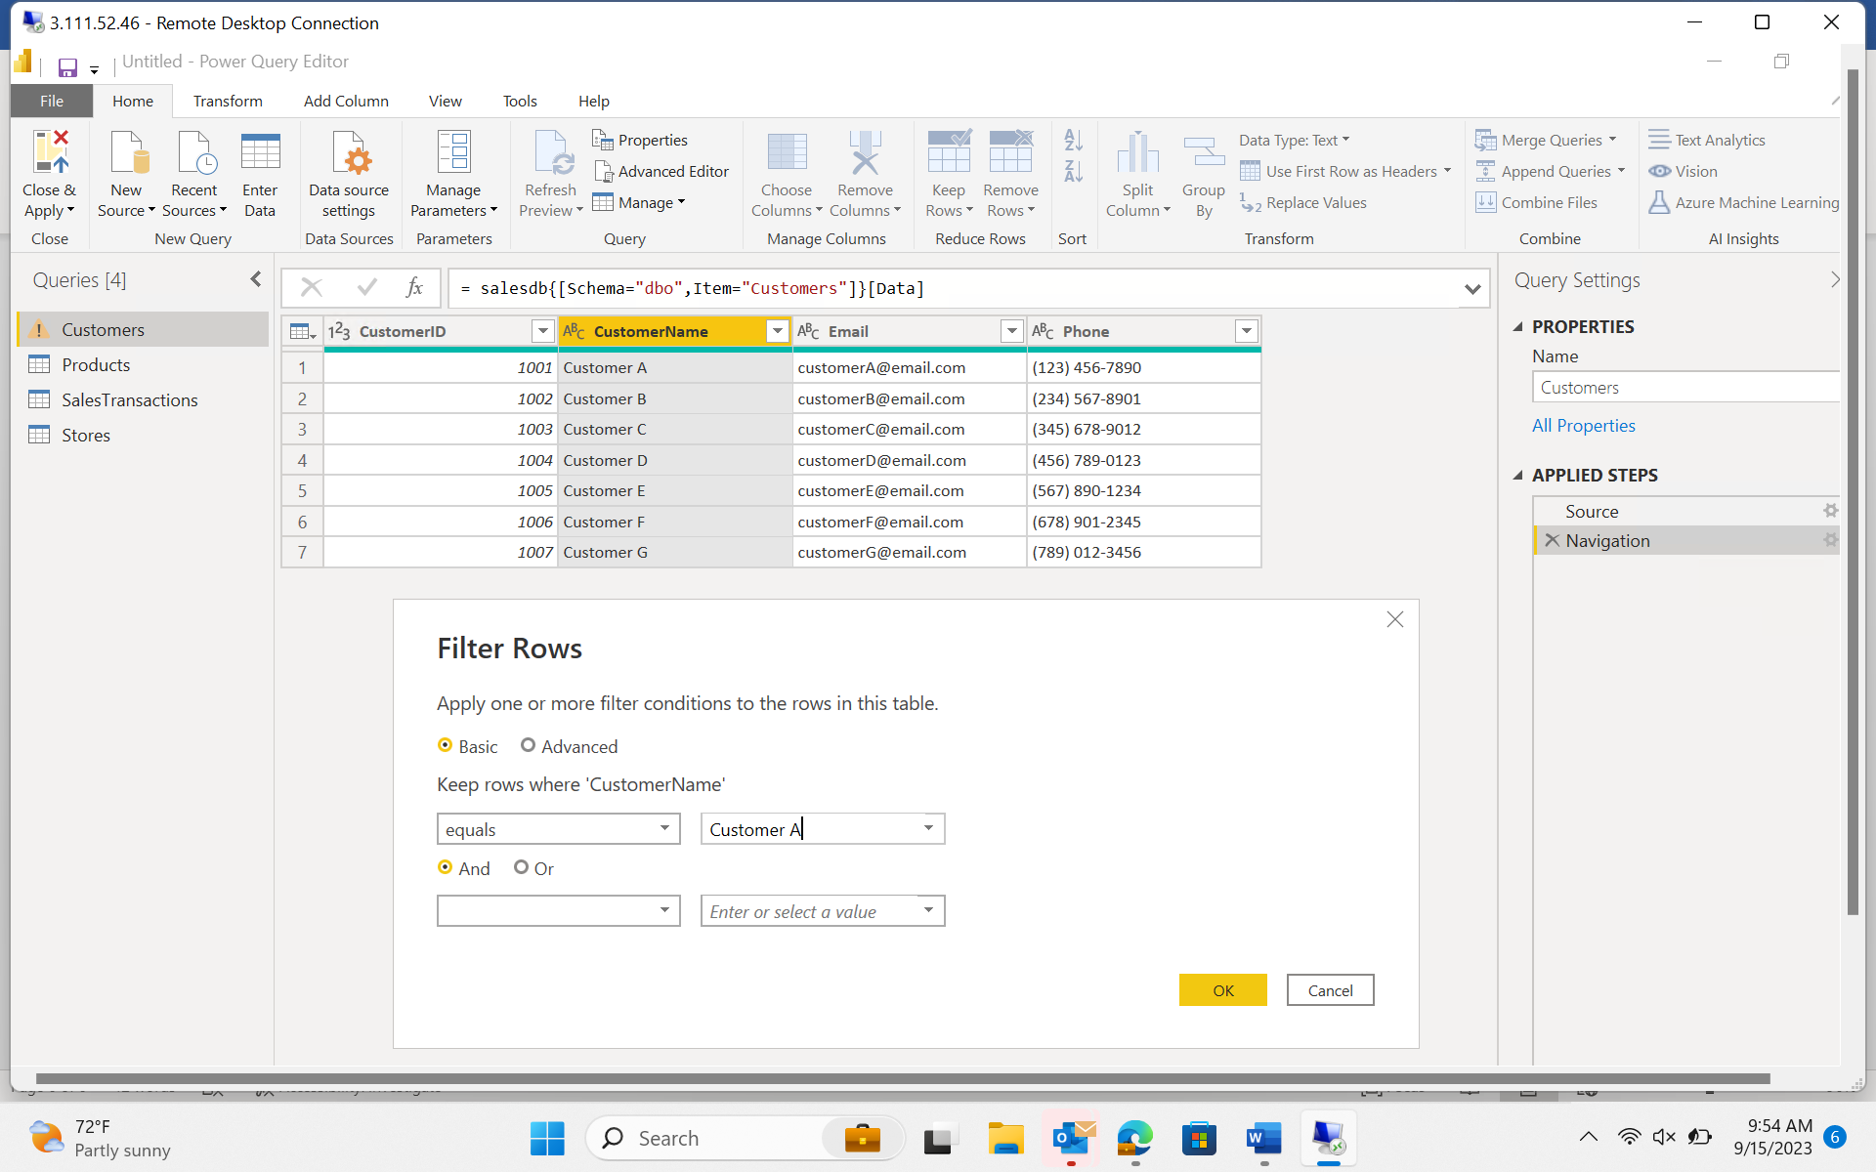

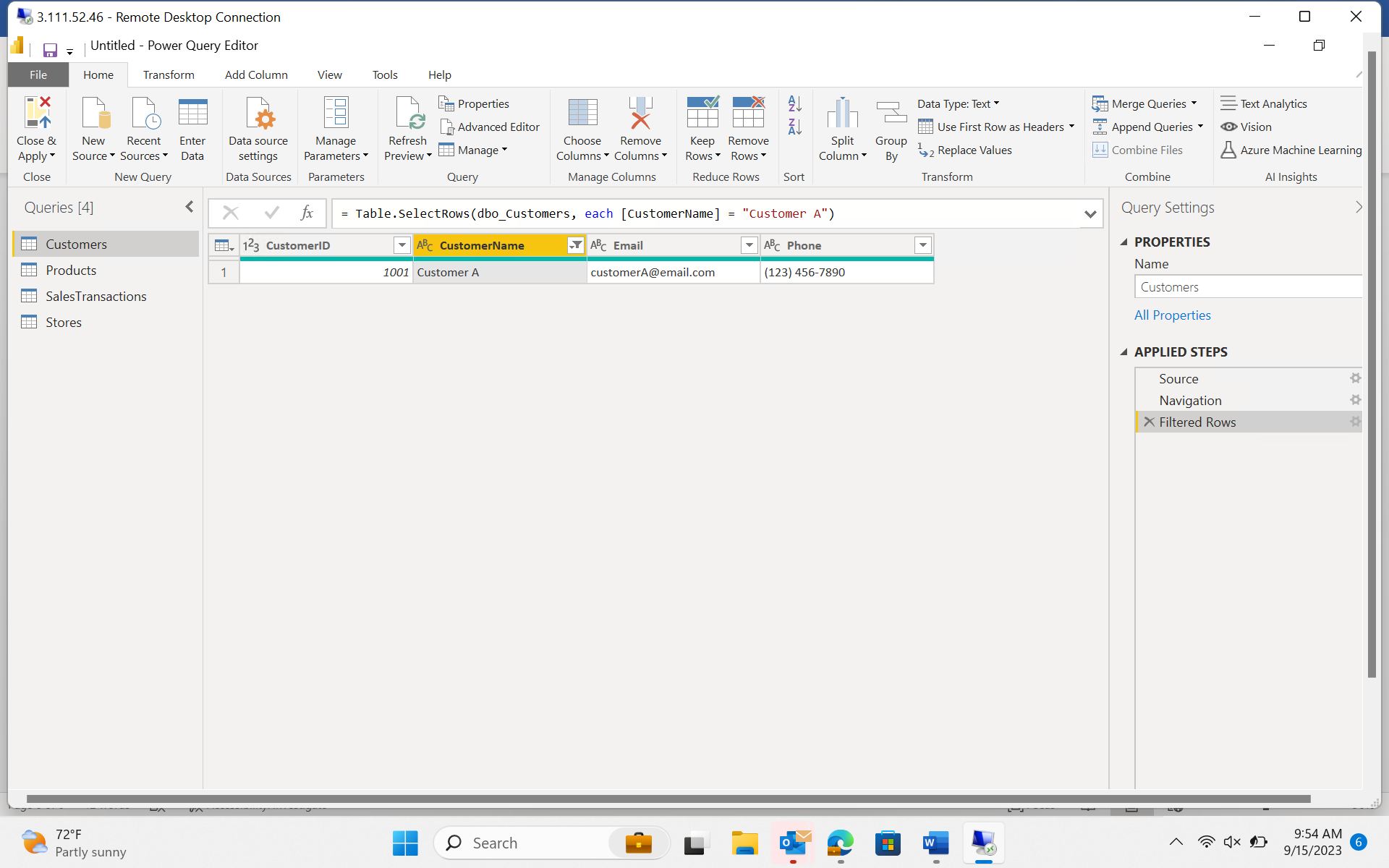

1. Data Modelling

Create Relationships

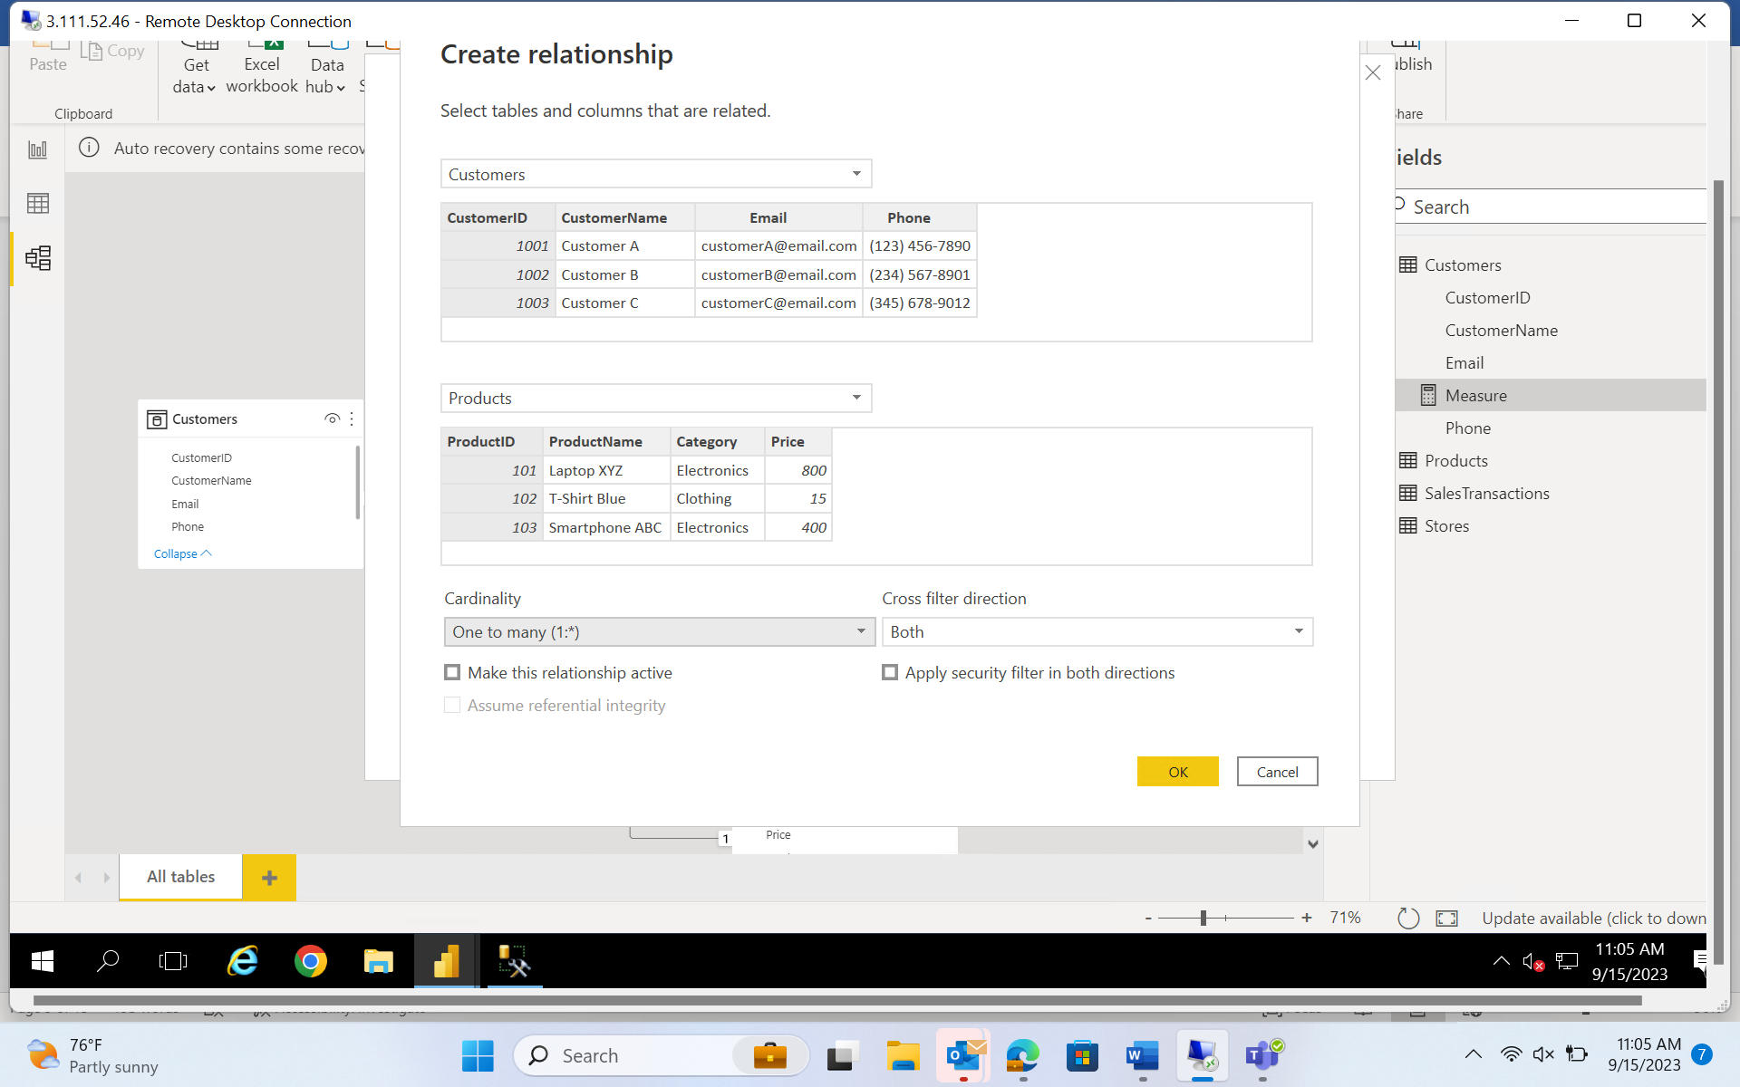

Create Hierarchy

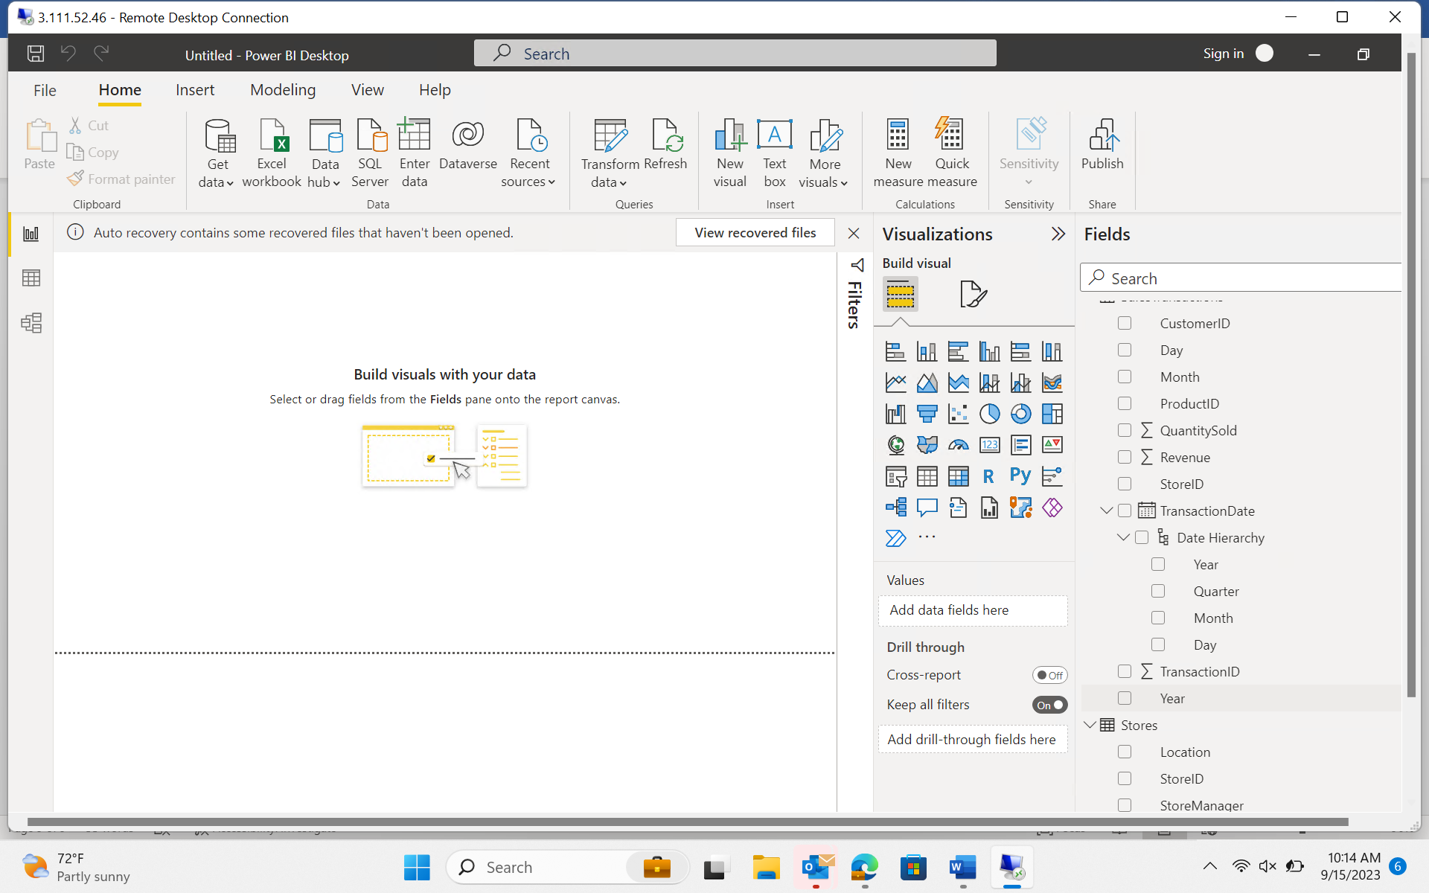

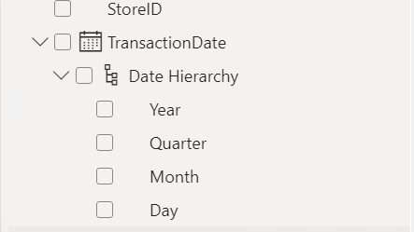

Requirement 4: Business Queries and Analysis

1. Who are the top-spending customers based on their total purchase amount?

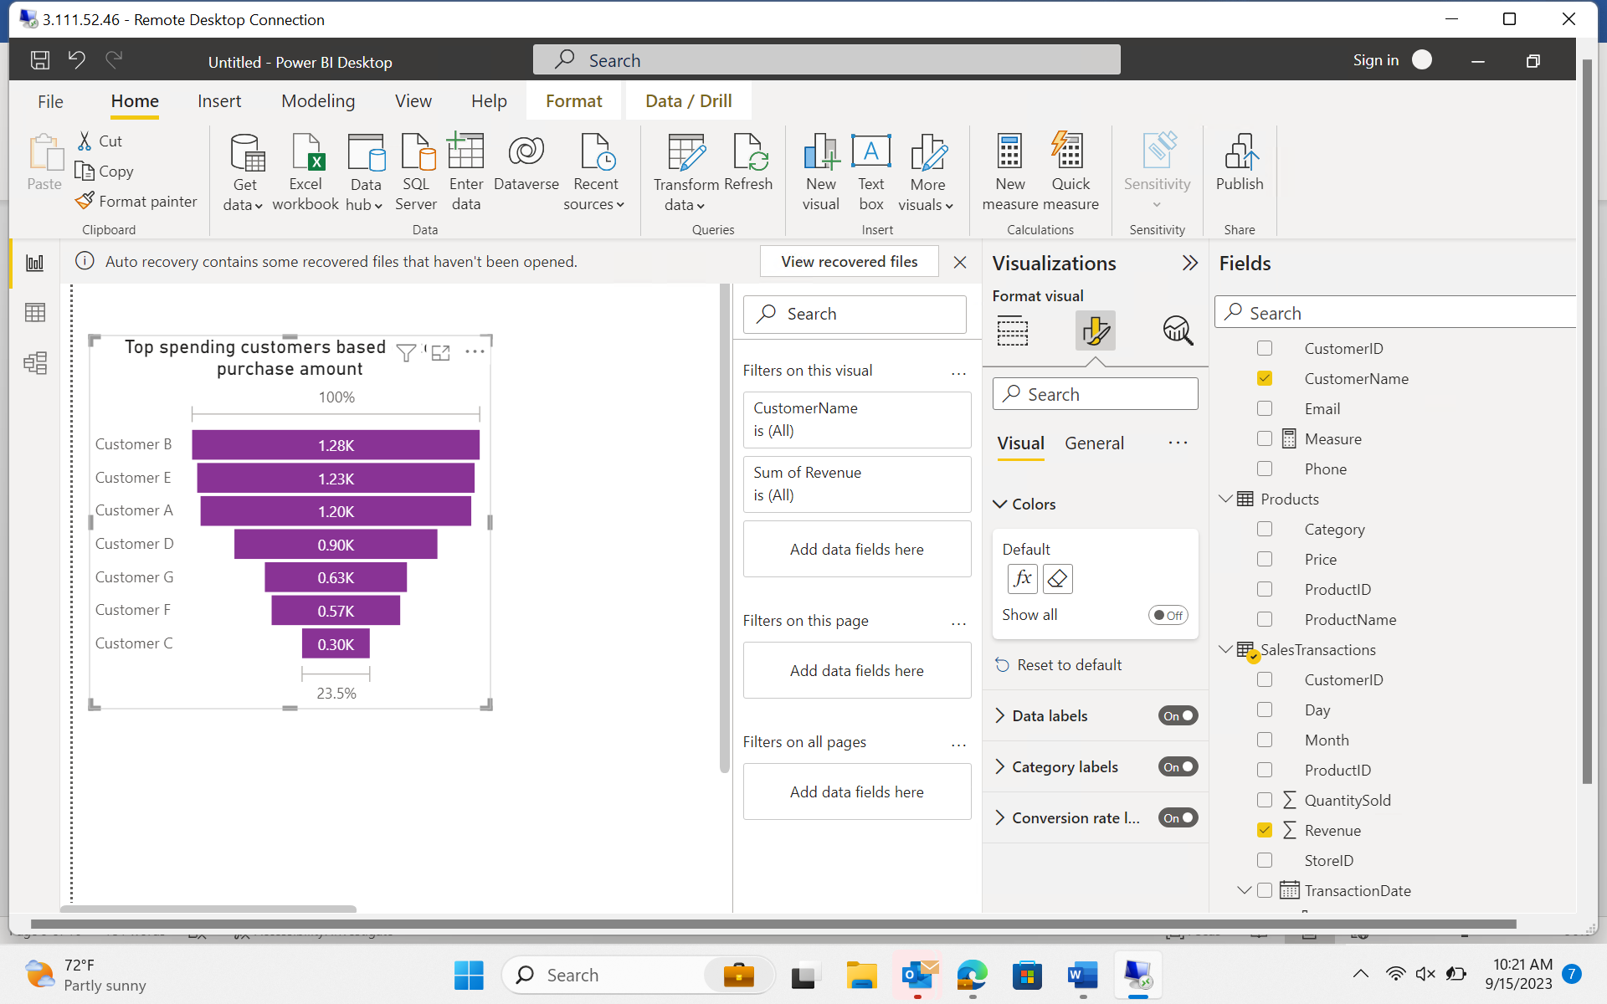

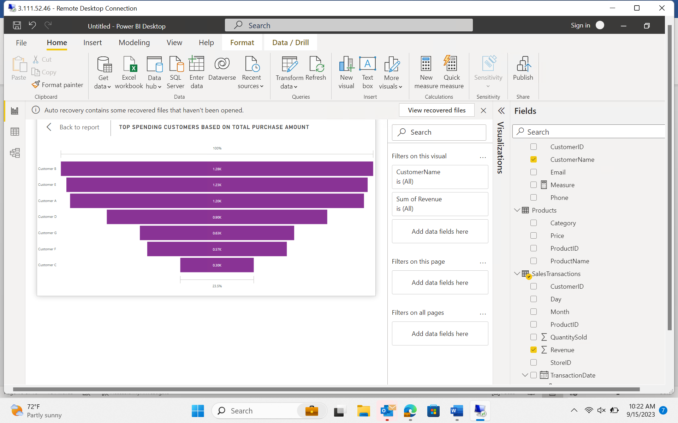

1. How is sales revenue distributed among different store managers?

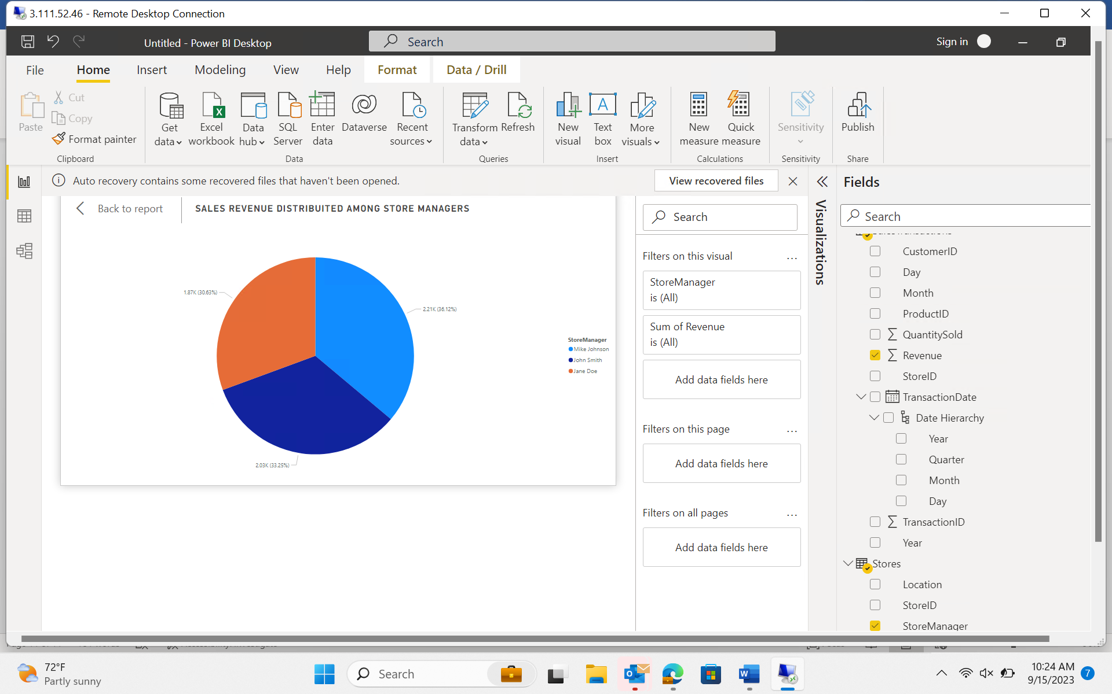

1. What is the average price of products in each category?

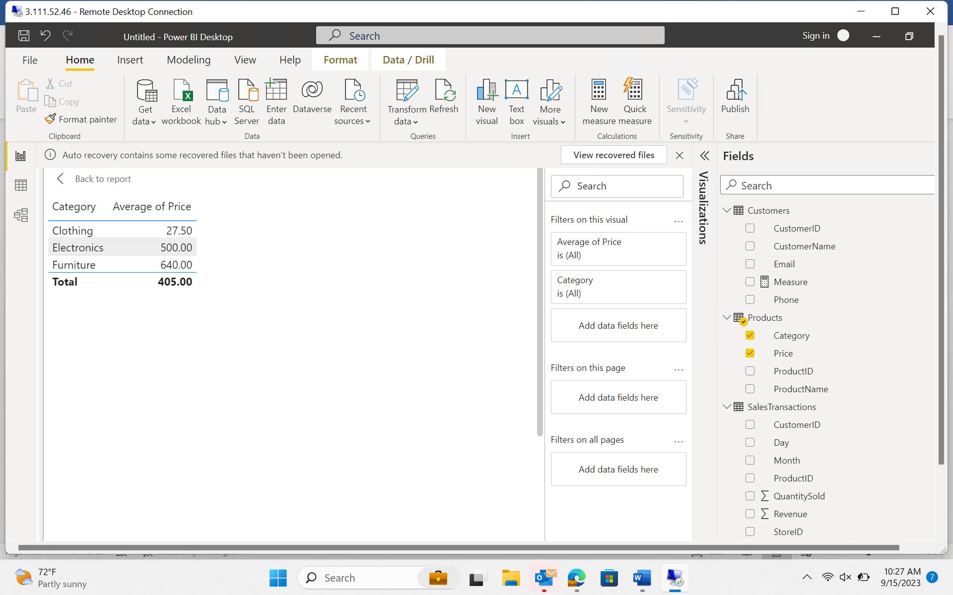

1. Are there specific days of the week when sales are higher?

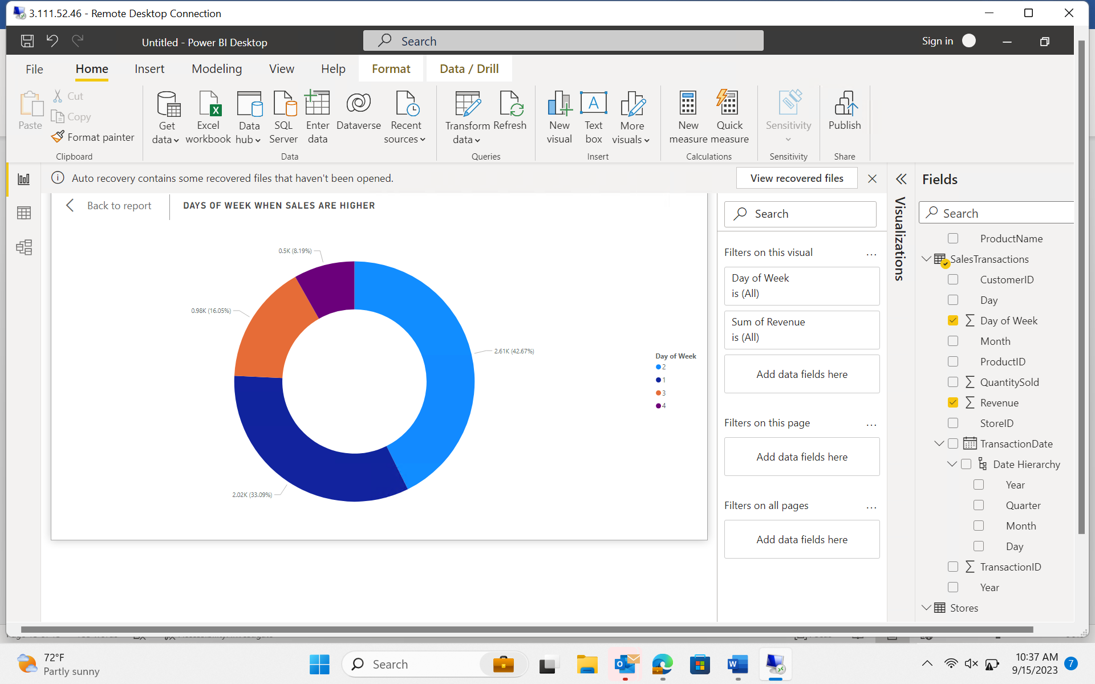

1. How do sales trends vary by product category on a monthly basis?

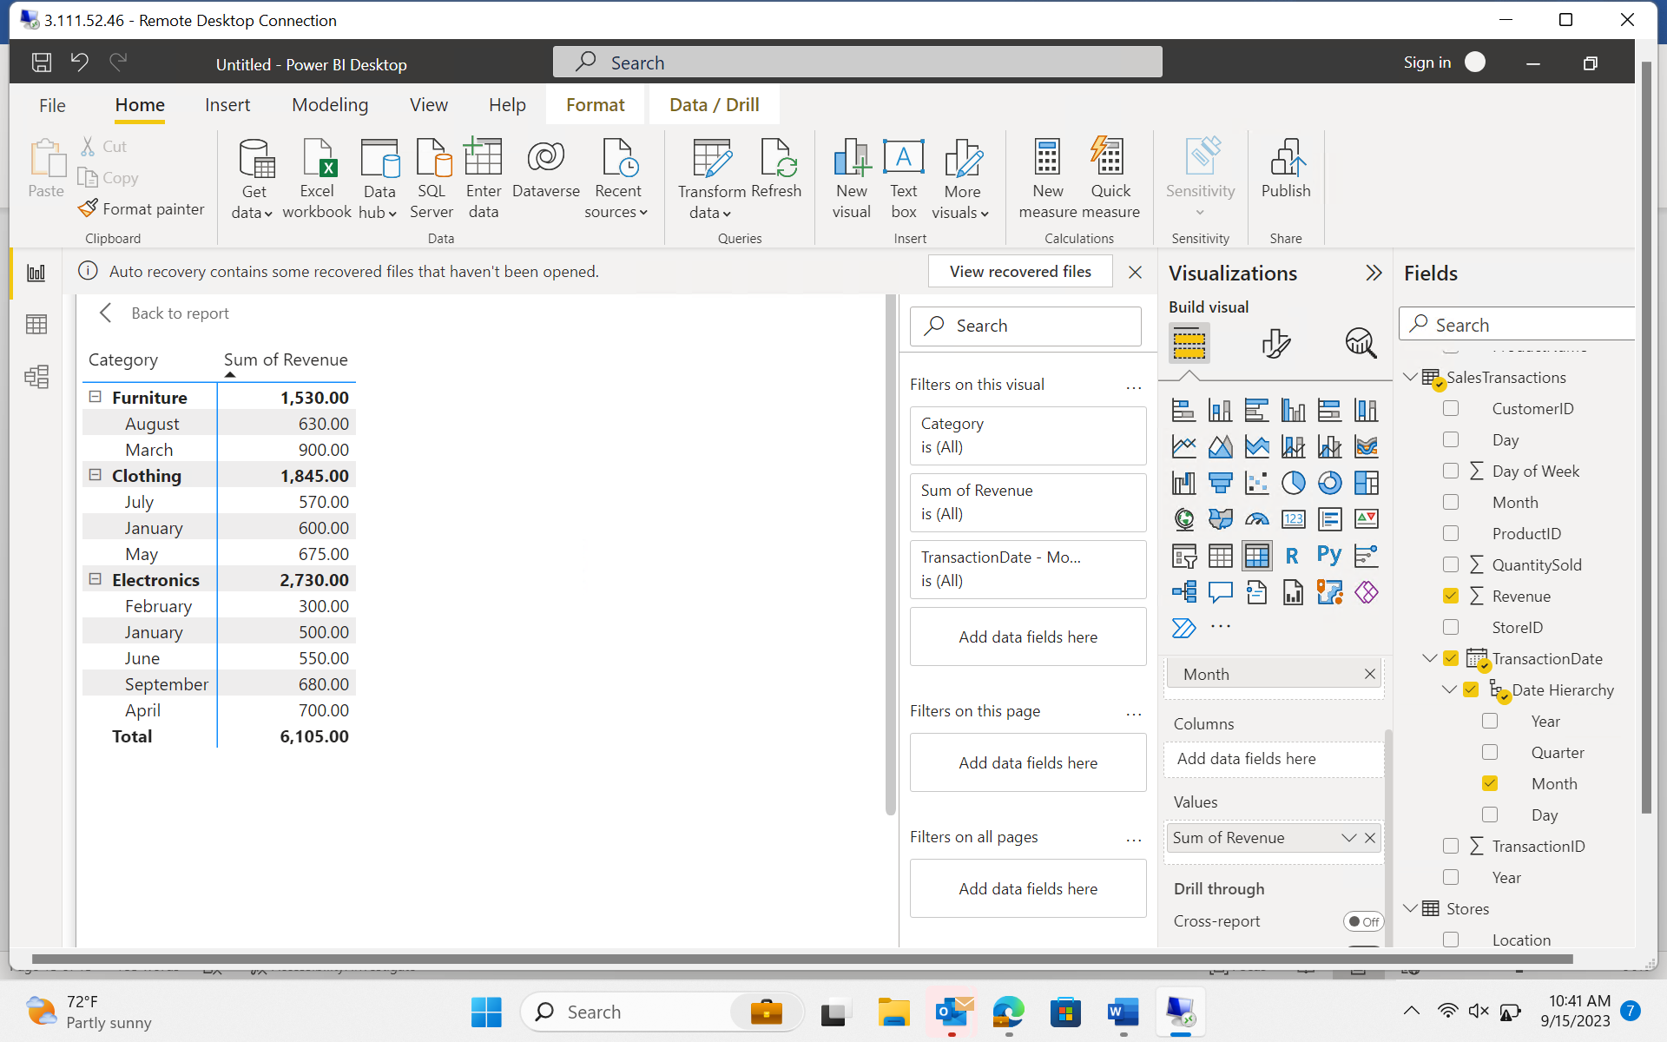

1. What percentage of products account for 80% of total sales revenue?

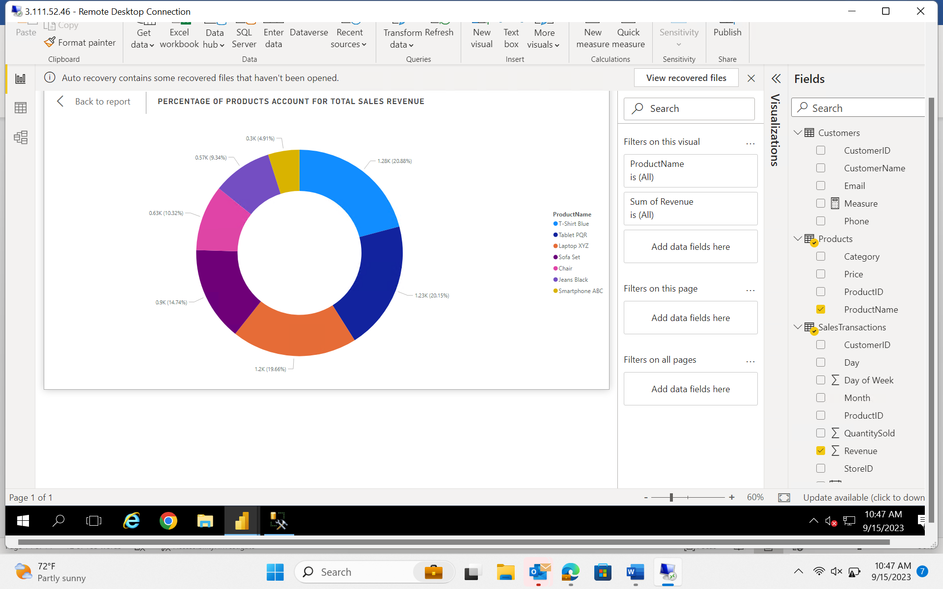

1. Are there any trends in repeat customer purchases?

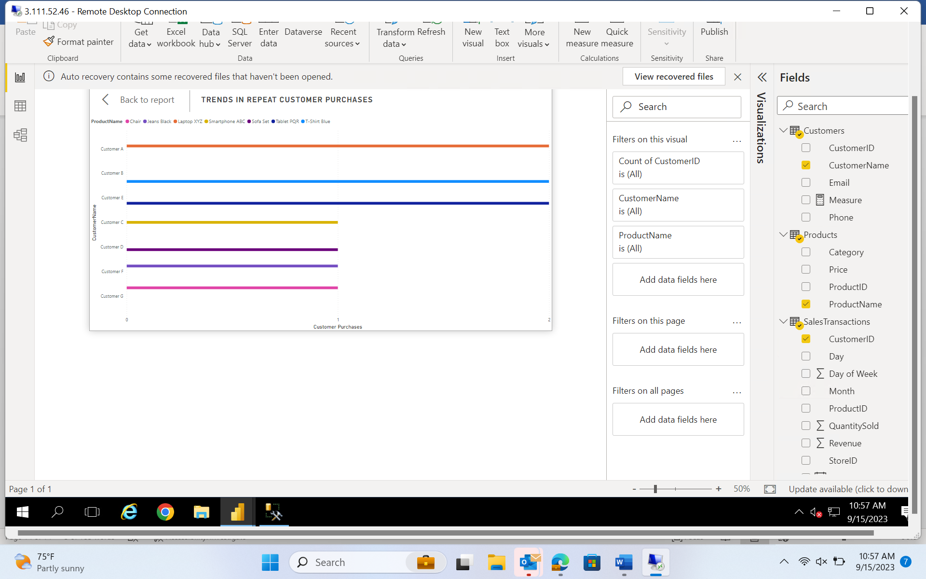

1. Which product categories perform best at each store location?

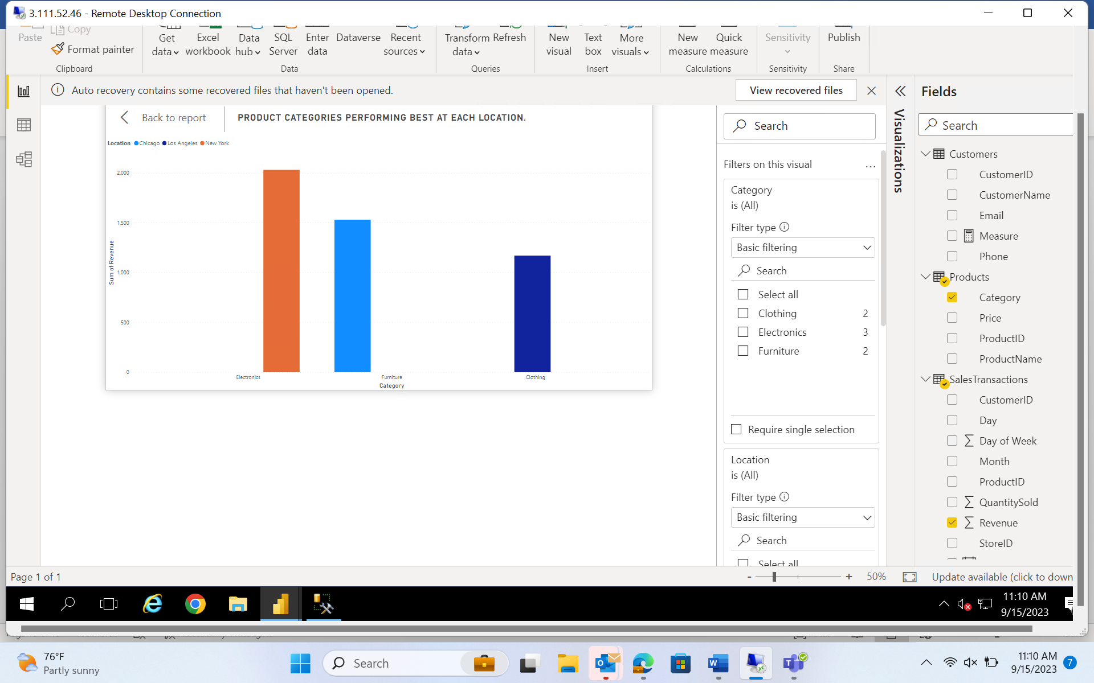

1. Are there any seasonal patterns or trends in sales for specific products or categories?

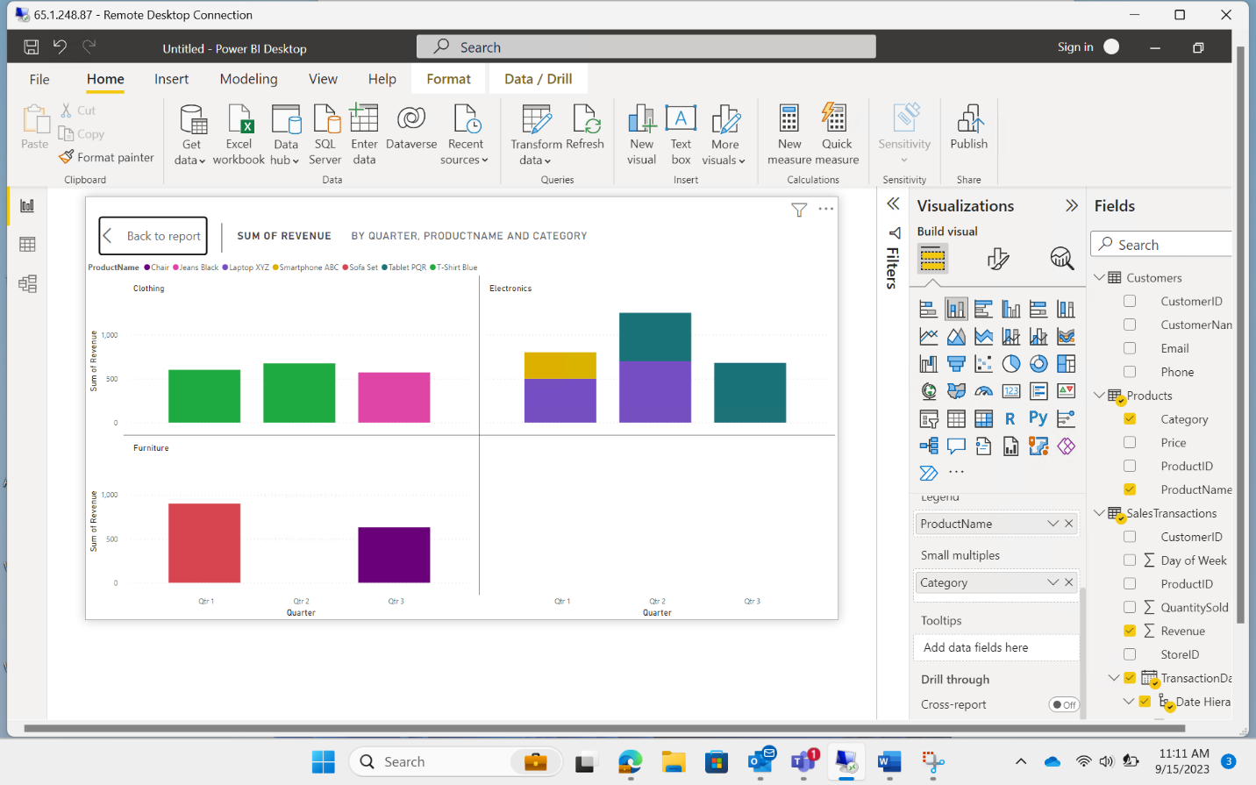

1. Can customers be segmented into high, medium, and low-value segments based on their purchase history.

